**Image processing HW6 Name:武敬祥 ID:b06611032**

# GUI

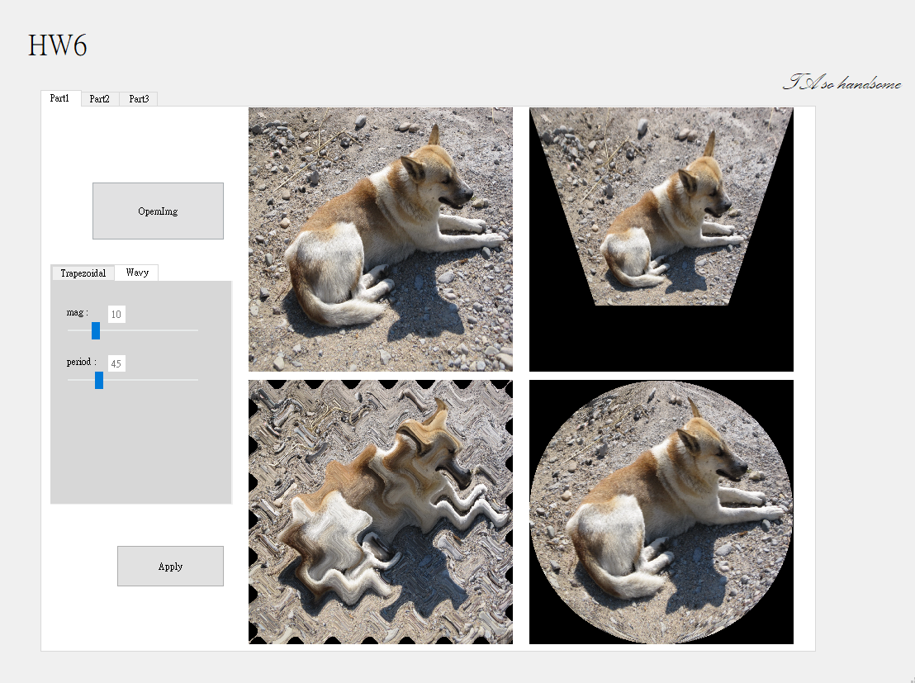

# Part 1



## Trapezoidal

The top right image is an implementation of trapezoidal transformation. The principle of this transformation is that transforming the pixel to pixel with a 3X3 transformation matrix H. In order to acquire ideal transformation matrix, we need to specify four 1-to-1 mapping points. In accordance with the following equation

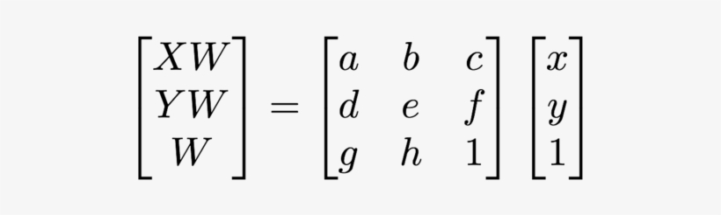

We can acquire a to h and find out the transformation matrix H. Switching to “Trapezoidal” tab, we can adjust the offset_x and offset_y to change the transformation image.

## Wavy

The bottom left image is wavy image. The principle of this transformation is moving every pixel by the following sinusoid equation

where I and j are x and y of the original image, u and v are x and y of the warping image. Apparently, mag represents the magnitude of this sin function, and per represents the period. Both of them can be adjusted in the “Wavy” tab.

## Circular

The bottom right image is circular image. The implementation of this transformation is simple but trivial. In short, we resize every row of original image such that every row can be tucked into every row of a specific circle shape.

# Part 2

# Part 3

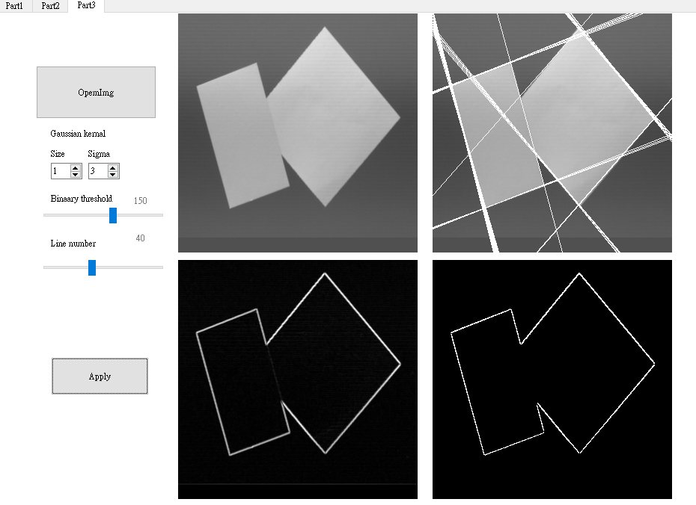

The top right is original image, the bottom left is edge-detected image, the bottom right is binary image and the top right is houghline-detected image.

In order to get the houghline detected image, we have to go through the following steps

1. Converting RGB image to Gray scale image
2. Applying gaussian filter
3. Finding edge by edge detecting filter(Sobel, Canny, etc.)
4. Converting edge image to binary image
5. Applying hough line algorithm to binary image

We can adjust the size and sigma of gaussian filter, binary threshold and the number of detected line. Applying gaussian filter can eliminate the noise which will bring about a lower accuracy of edge detection. In this case, the four edges of original image are so clear that we can disable the gaussian filter. The different threshold can pose a huge effect to the result of finding lines.

## Threshold = 150

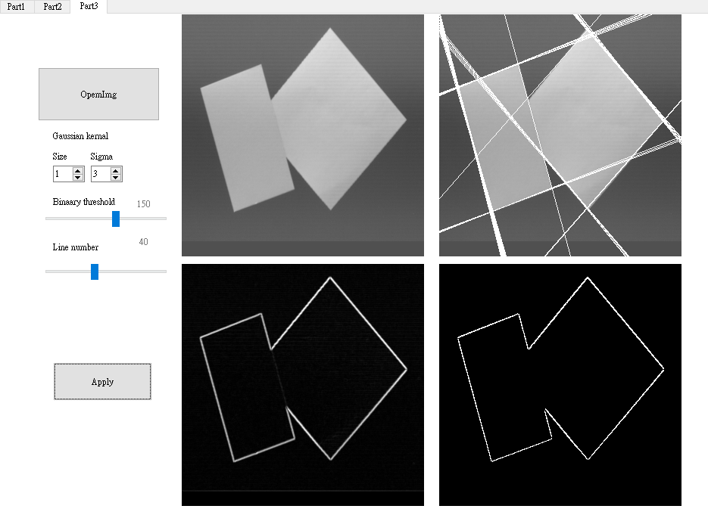

## Threshold = 110

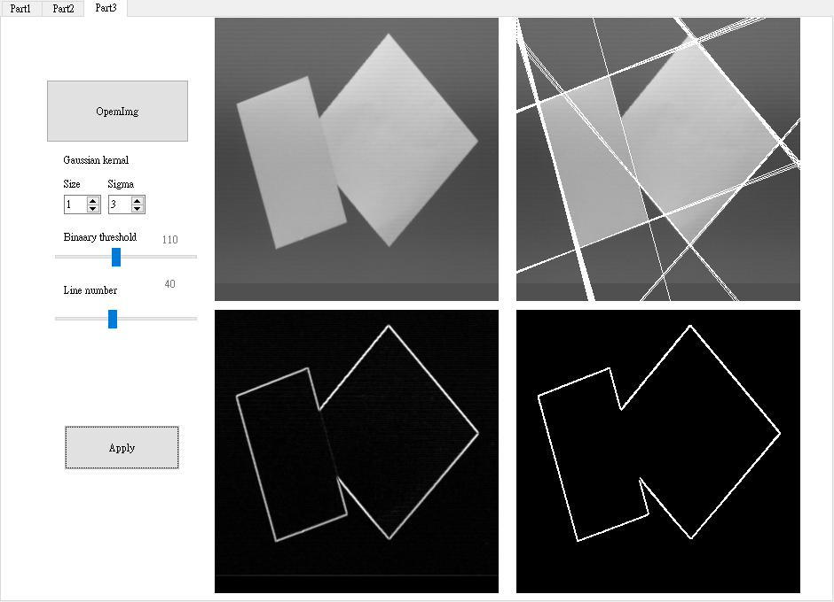

## Threshold = 70

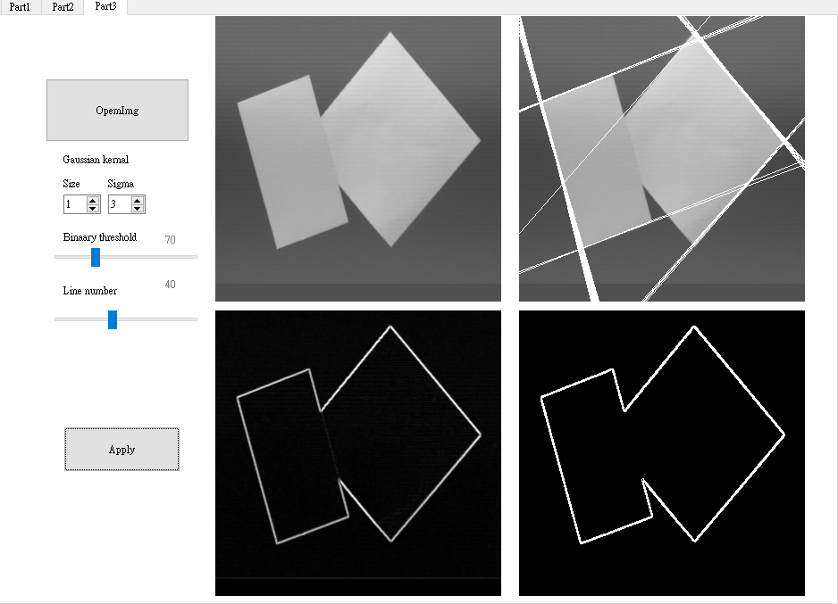

With the same number of detected line, when threshold equals to 70, the lines are much more concentrated on the specific edge than the threshold equals to 150. This phenomenon is because that a smaller threshold lead to a wider edge in binary threshold image, resulting that the peaks of rou-theta accumulator focus on some certain area. In order to illustrate the importance of gaussian filter, we apply hough line-detected algorithm to an image with more environment noise.

## Without gaussian filter

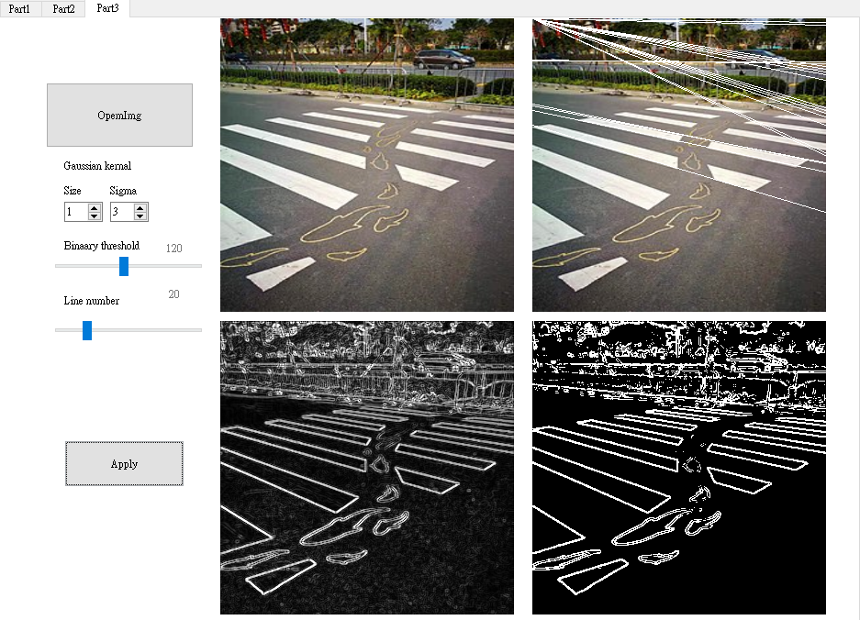

## With gaussian filter (kernel size =3)

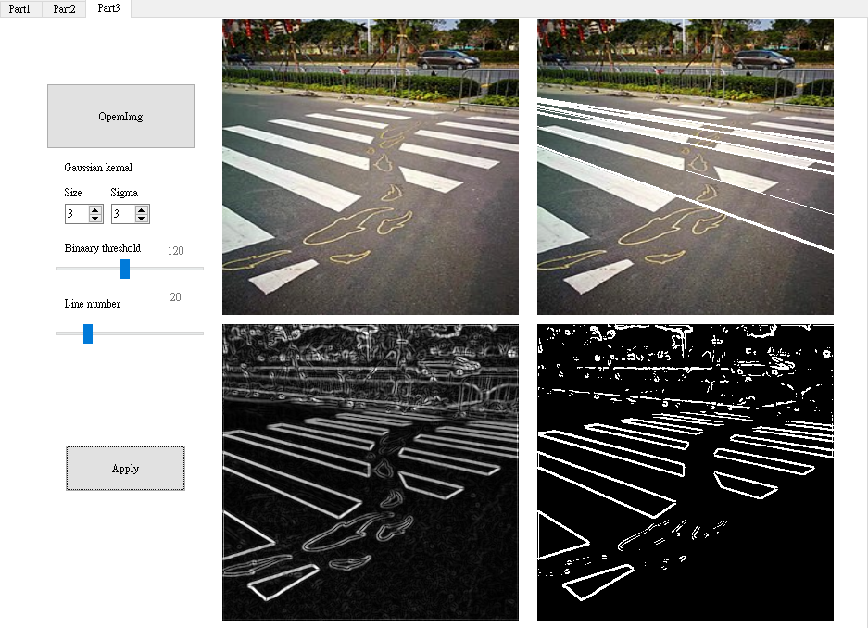

The result is much better.